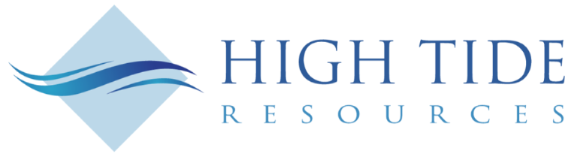

High Tide Resources Reports 205.16 Metres of 32.06% Fe at Labrador West Iron Project
Includes 69.5 Metres of 34.52% Fe from Near Surface

TORONTO, Ontario, August 10, 2022 – High Tide Resources Corp. (“High Tide” or the “Company”) (CSE: HTRC) is pleased to report assay results (Table 1) from drill hole 22LB0060 from the 2022 spring/summer drilling program at its flagship Labrador West Iron Project (the “Project” or “Property”). The Project is located 20 km northeast and adjacent to IOC/Rio Tinto’s Carol Lake Mine complex in Labrador City, Newfoundland (Figure 1).
Steve Roebuck, Director, President & Interim CEO of High Tide states, “We are pleased to report a very good first drill intercept that is a desirable combination of both high-grade oxide iron over an extensive interval width. The location of this drill hole confirms the broad continuity of the iron formation in between historic and recent drill holes providing the team with a high-level of confidence as we prepare for a maiden resource later this year.”
Table 1: Significant Iron Intercepts of Oxide-Dominated Iron Formation
DDH ID | Easting (NAD83 Zone 19N) | Northing (NAD83 Zone 19N) | Elevation (m) | Dip (Deg) | From (m) | To (m) | Drill Width (m) ** | Fe Total (%) *
22LB0060 | 650892 | 5895630 | 559 | -90 | 4.60 | 209.76 | 205.16 | 32.06
including |  |  |  |  | 4.60 | 74.10 | 69.50 | 34.53
including |  |  |  |  | 74.10 | 150.20 | 76.10 | 28.66
including |  |  |  |  | 150.20 | 209.76 | 59.56 | 33.53
* Significant FeT (%) values are weighted length averages with a minimum total Fe grade of 24 wt. %
** True Widths are estimated to be 80 to 90 % of drill width

A total of 2298 metres of core was drilled with iron mineralization visually identified in all seven HQ/NQ-diameter diamond dill holes (Figure 2). The 2022 drill program was designed to in-fill between recent and historical drill holes and test for depth and lateral continuity in preparation for a maiden resource later this year. Drill hole 22LB0060 was drilled to a depth of 272.0 metres intersecting 257.72 metres of Sokomon Iron Formation, including 205.16 meters of the oxide-dominated Middle Sokomon Iron Formation, before being halted in the barren quartz-rich Wishart Formation (Figure 3).
The oxide facies of the Sokomon Iron Formation are dominated by the iron oxide minerals, hematite and magnetite accompanied by quartz occurring predominantly as chert. There may be accessory carbonates (calcite or dolomite), silicates, and, rarely, manganese oxides or carbonates. Production experience in the Labrador Trough indicates that hematite and magnetite in such a lithological setting tend to be readily easily recoverable using modern beneficiation methods, and produce high purity, desirable iron concentrates.
The drill core was logged and sampled at High Tide’s secure core shack located in Labrador City with all samples shipped to Activation Laboratories in Ancaster, Ontario for sample preparation and analytical testing. Assays will be reported in a timely manner.
Labrador West Iron Project
The Labrador West Iron Project is comprised of four mineral licences (99 mineral claims), 2,475 hectares in size. High Tide plans to quickly advance the Project through the drilling phase, release a maiden resource and potentially commence a PEA level study all within the first 12 months of going public. Explored and drilled by Rio Tinto Exploration from 2010 to 2012, and by High Tide Resources in 2020 & 2022, with 27 completed holes and approximately 7,500 metres of drill core the Project is ready for rapid advancement. Note that 30 drill holes were collared, but three Rio Tinto era holes were abandoned and re-drilled for technical drilling issues.
Located only 20 kilometres northeast of Labrador City, the Project is proximal to all the critical infrastructure required to explore and develop a major new iron deposit, in the heart of the southern Labrador Trough.

Iron and the Western Labrador Trough Infrastructure Advantage

The Labrador Trough of western Labrador and adjoining Quebec constitutes Canada’s primary iron producing district and is host to world-class deposits that have been mined for more than half a century. These have produced over 2 billion tonnes of iron ore to date and are considered to have very significant growth potential. The high quality of the deposits in the region allows for a wide range in product diversity, which includes premium fines, concentrate and pellet grades.
The Property is strategically located near the mining communities of Wabush and Labrador City in the province of Newfoundland & Labrador and Fermont in Quebec. The area is home to the shovel-ready Kami Deposit, Champion Iron Ore’s Bloom Lake Mine, Arcelor Mittal’s Mont-Wright Mine, Tacora Resources’ Scully Mine, the Julienne Lake Deposit and Rio Tinto IOC’s Carol Lake Mine.
The Wabush and Labrador City region is very well served with skilled labour and a highway as well as access to abundant low-cost hydroelectricity and a common carrier railway. The railway has 80 million tonnes per year of capacity for transport of iron products to the deep-water port of Sept Isles, Quebec, which provides year-round access to global markets.
About High Tide
High Tide is focused on, and committed to, the development of advanced-stage iron ore and battery metal projects in Canada using industry best practices combined with a strong social license from local communities. High Tide is earning a 100% interest the Labrador West Iron project located proximal to IOC/Rio Tinto's 23 mtpy Carol Lake Mine in Labrador City, Labrador. High Tide is earning a 100% interest in the Clearcut Lithium Project in the emerging Cadillac-Pontiac lithium camp in Quebec. High Tide also holds a 100% interest in the Lac Pegma Copper-Nickel-Cobalt deposit located 50 kilometres southeast of Fermont, Quebec. High Tide's majority shareholder is Avidian Gold (TSX.V: AVG & OTCQB: AVGDF).
Further details on the Company, including a NI 43-101 technical report on the Labrador West Iron property can be found on the Company’s website at www.hightideresources.com .
Qualified Person Statement
All scientific and technical information disclosed in this news release was prepared and approved by Steve Roebuck, P.Geo., President & VP Exploration of High Tide Resources Corp. and a Qualified Person as defined by NI 43-101. Scientific and technical information pertaining to the 2022 drill program in this news release was reviewed and approved by Ryan Kressall, M.Sc., P.Geo., Director of Geoscience, Mercator Geological Services Limited and a Qualified Person as defined by NI 43-101.
For further information, please contact:

Steve Roebuck
Director, President & Interim CEO
Mobile: (905) 741-5458
Email: sroebuck@hightideresources.com
Neither Canadian Securities Exchange nor its Regulation Services Provider (as that term is defined in the policies of the Canadian Securities Exchange) accepts responsibility for the adequacy or accuracy of this news release.
Sampling Protocol, Analytical Procedures, and QAQC
Mercator Geological Services supervised the Phase One diamond drilling program. This included designing and implementing a comprehensive QAQC program consistent with CIM best practice methods. Core was delivered to a secured location for geological and geotechnical logging, and sampling. After core logging, core was marked for sampling and splitting. QAQC certified reference materials were used for blanks and standards and inserted at a rate of every alternating 10th sample. Quarter core duplicates were also collected every 40th sample and lab duplicates (alternating between coarse reject and pulp splits) were also analyzed every 40th sample. All split samples were stored in a secure location in sealed shipping bags prior to shipment to the laboratory for assay testing.
Sample shipments were securely delivered via courier to Activision Laboratories (“ActLabs”) in Ancaster, Ontario for sample preparation and analytical testing. Sample preparation was through the laboratory’s standard rock preparation protocol that begins with jaw crushing followed by pulverization of a sample split (250g) to generate a pulp having 95% passing 0.105 mm grain size. Iron (Fe) content was measured using the Lithium Metaborate fusion technique. Prior to fusion, the loss on ignition (LOI), which includes H₂O+, CO₂, S and other volatiles, is determined from the weight loss after roasting the sample. The fusion disk is made by mixing the roasted sample with a combination of lithium metaborate and lithium tetraborate. Samples are fused in Pt crucibles using an automated crucible fluxer and automatically poured into Pt molds for casting. Samples are then analyzed on a Panalytical Axios Advanced wavelength dispersive XRF. Actlabs is an accredited commercially-operated laboratory analytical services firm that is ISO 17025 registered. Actlabs is independent of High Tide Resources, Avidian Gold, and Mercator.
Forward-looking information
This news release includes certain "forward-looking statements" which are not comprised of historical facts. Forward-looking statements include estimates and statements that describe the Company’s future plans, objectives or goals, including words to the effect that the Company or management expects a stated condition or result to occur. Forward-looking statements may be identified by such terms as “believes”, “anticipates”, “expects”, “estimates”, “may”, “could”, “would”, “will”, or “plan”. Since forward-looking statements are based on assumptions and address future events and conditions, by their very nature they involve inherent risks and uncertainties. Although these statements are based on information currently available to the Company, the Company provides no assurance that actual results will meet management’s expectations. Risks, uncertainties and other factors involved with forward-looking information could cause actual events, results, performance, prospects and opportunities to differ materially from those expressed or implied by such forward-looking information. Forward looking information in this news release includes, but is not limited to, listing of the Company’s shares on the CSE, the Company’s objectives, goals or future plans, statements, exploration results, potential mineralization, the estimation of mineral resources, exploration and mine development plans, timing of the commencement of operations and estimates of market conditions. Factors that could cause actual results to differ materially from such forward-looking information include, but are not limited to: the ability to anticipate and counteract the effects of COVID-19 pandemic on the business of the Company, including without limitation the effects of COVID-19 on the capital markets, commodity prices supply chain disruptions, restrictions on labour and workplace attendance and local and international travel, failure to receive requisite approvals in respect of the foregoing, failure to identify mineral resources, failure to convert estimated mineral resources to reserves, the inability to complete a feasibility study which recommends a production decision, the preliminary nature of metallurgical test results, delays in obtaining or failures to obtain required governmental, environmental or other project approvals, political risks, inability to fulfill the duty to accommodate First Nations and other indigenous peoples, uncertainties relating to the availability and costs of financing needed in the future, changes in equity markets, inflation, changes in exchange rates, fluctuations in commodity prices, delays in the development of projects, capital and operating costs varying significantly from estimates and the other risks involved in the mineral exploration and development industry, and those risks set out in the Company’s public documents filed on SEDAR. Although the Company believes that the assumptions and factors used in preparing the forward-looking information in this news release are reasonable, undue reliance should not be placed on such information, which only applies as of the date of this news release, and no assurance can be given that such events will occur in the disclosed time frames or at all. The Company disclaims any intention or obligation to update or revise any forward-looking information, whether as a result of new information, future events or otherwise, other than as required by law.
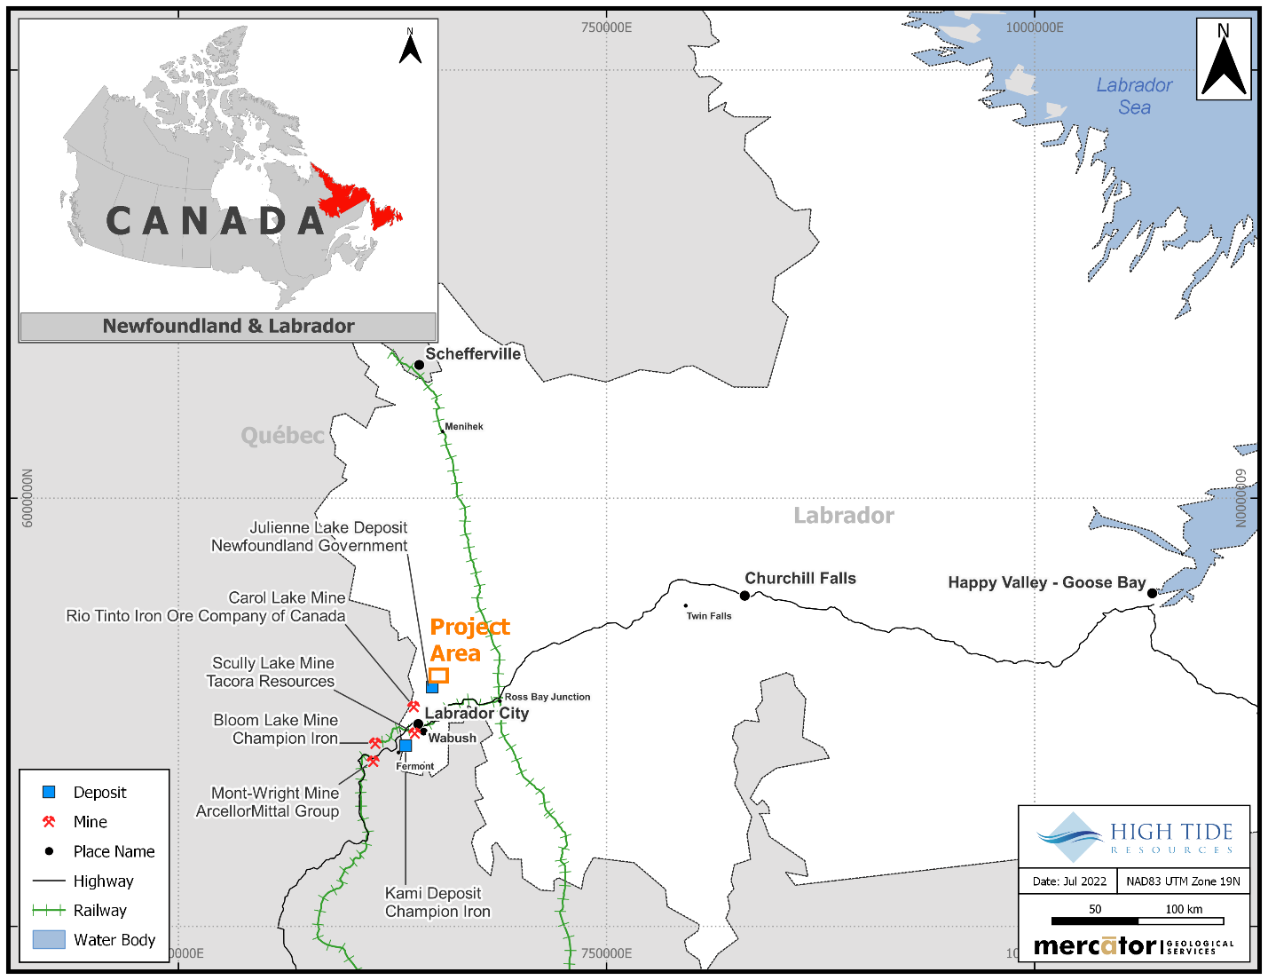
Figure 1: Labrador West Iron Project location map

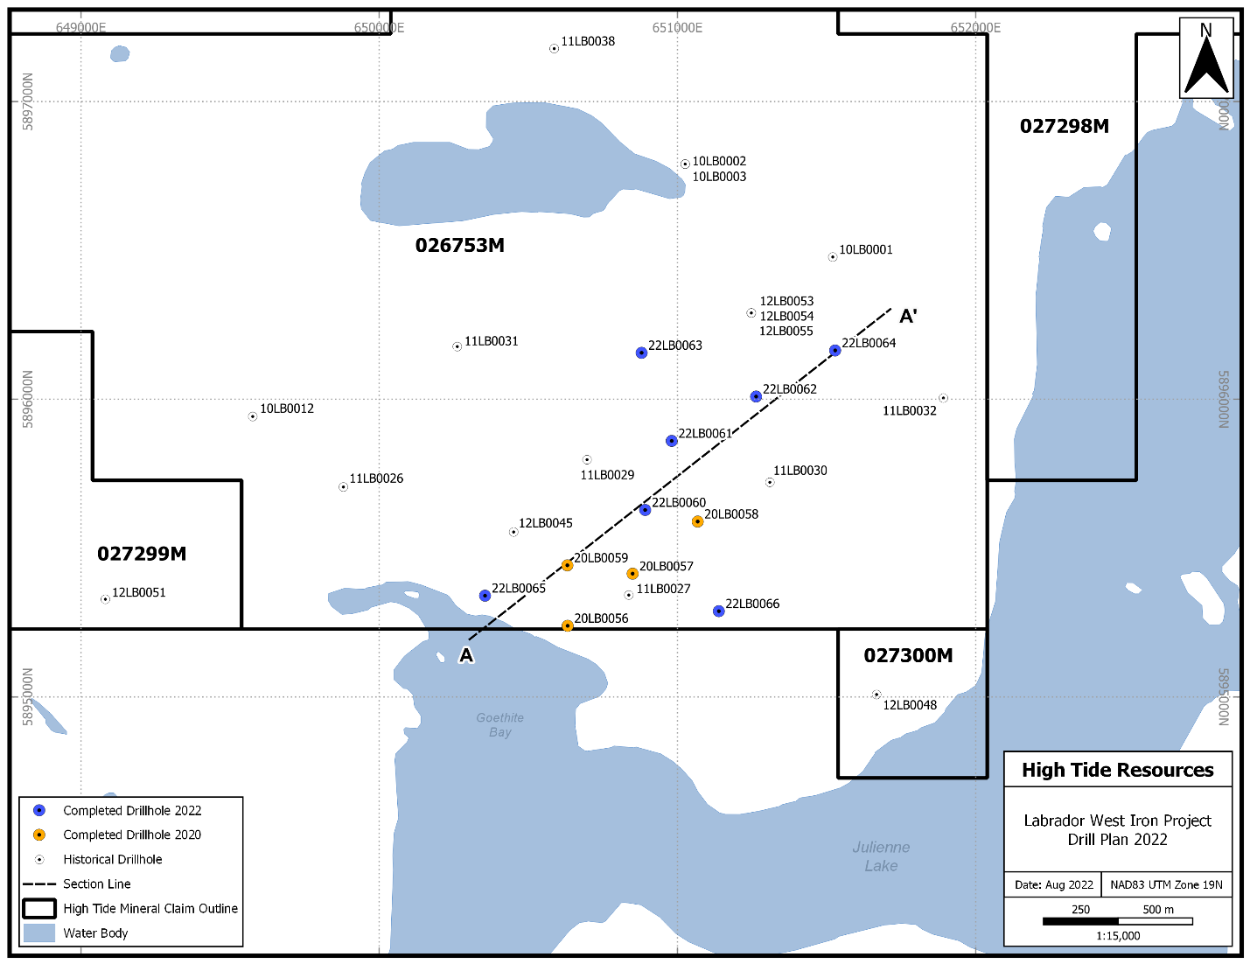
Figure 2. Labrador West Iron Project drill hole location map

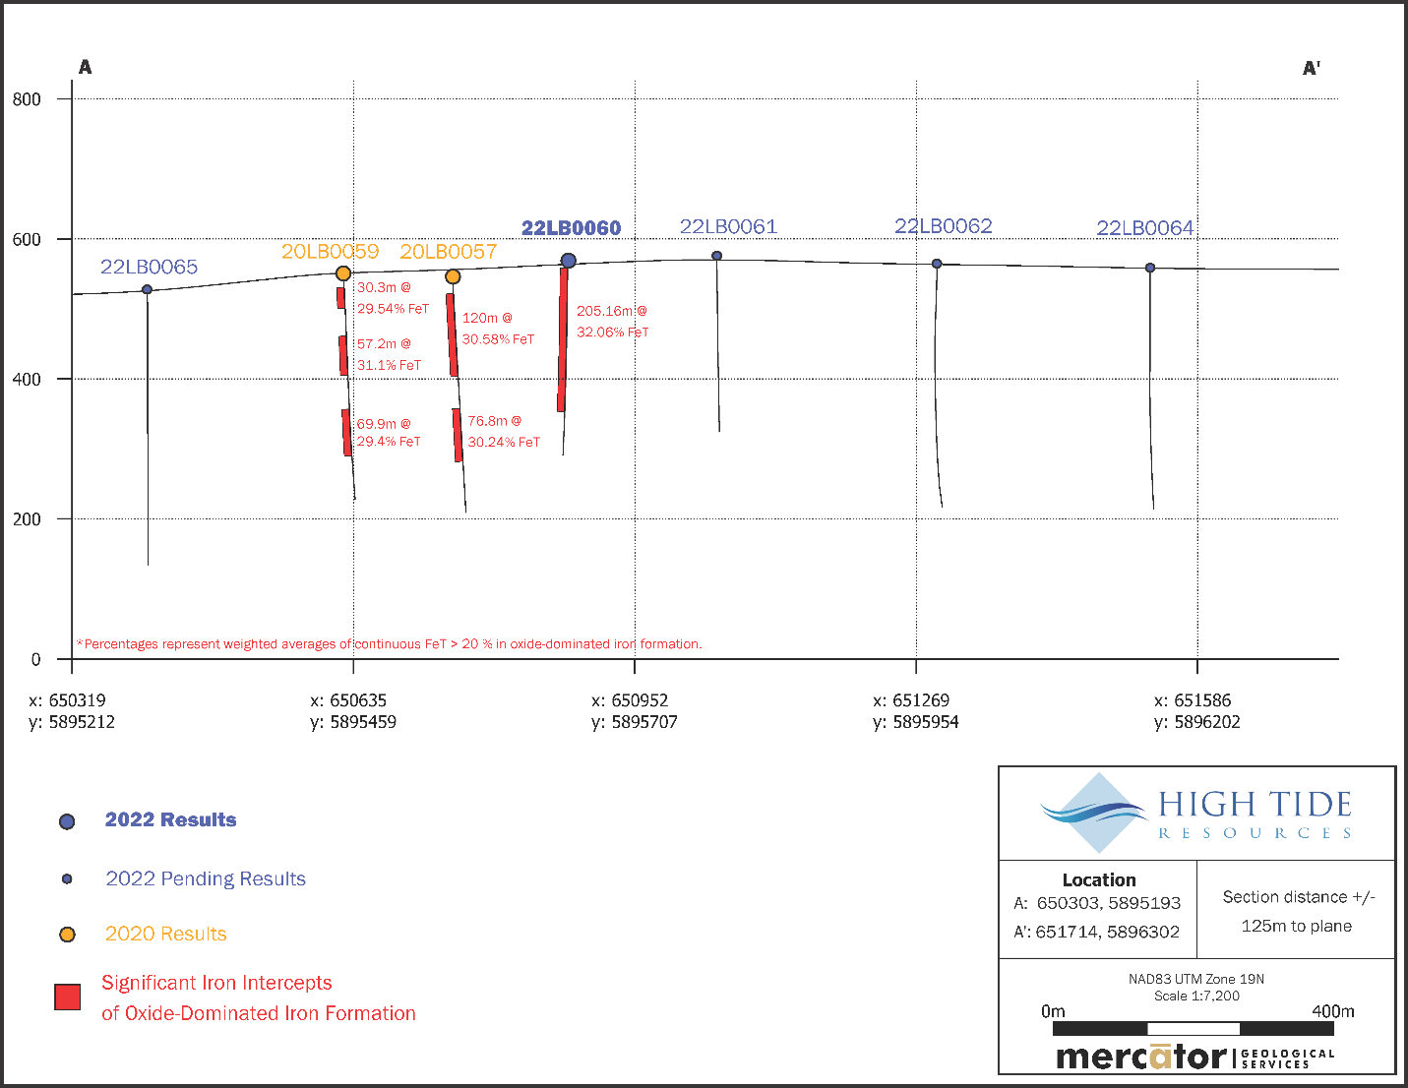
Figure 3. Labrador West Iron Project cross section looking NW along section A to A’ from Figure 2

