Historic Drill Logs Reveals Pegmatites Intersected in Multiple Drill Holes at Big Bang Lithium Project

TORONTO, February 15, 2023 – High Tide Resources Corp. (“High Tide” or the “Company”) (CSE: HTRC) is pleased to report that it has observed pegmatite in the historic drill logs of the Big Bang Lithium Project (“Big Bang” or the “Property”). Pegmatites are typically an important source of valuable lithium ore such as spodumene. It was revealed that notable widths of pegmatite were intersected in three holes drilled in 1968. The Property is located approximately 70 km east of Rock Tech Lithium’s advanced-stage Georgia Lake property and 275 km northeast of Thunder Bay, Ontario near the town of Geraldton (Figures 1, 2 & 3).
Report “DD RPT 10 GAMSBY LAKE” found within Ontario Assessment File 42E11SW0101 indicates that all three diamond drill holes (total footage 545 ft or 166 m) drilled in July & August of 1968 by Chimo Option intersected pegmatite. At the time, Chimo Option was targeting the pegmatite zones for uranium and only assayed for U₃O₈ with results in the nil to trace range. Of particular interest is hole H1 that was drilled N55E at -45 degrees to a length of 362 feet (110 m) with approximately 58% of the core being logged as pegmatite. Pegmatite intercepts ranged from <1 m to plus 20 metres with the final 24 metres logged as, and ending in, pegmatite (Figures 4, 5 & 6). The whereabouts of the drill core is currently unknown.
Steve Roebuck, Director, President & Interim CEO of High Tide states, “Big Bang is a very exciting property with pegmatites having been mapped on surface and intersected in three drill holes. The 1968 drill program was focused on assessing the uranium potential of the pegmatite with no attention paid to the lithium potential. The 55-year-old drill logs are vague and contain no details about the mineralogical composition of the pegmatite but the macro geological and structural conditions, in and around the property, create favourable conditions for lithium bearing minerals to be present. High Tide will conduct a site visit in the spring to assess the area and prepare for a summer exploration program.”
The property is underlain by a muscovite-bearing, S-type, peraluminous, fertile granite intruding metasediments (Figure 7). The Property occurs within 3 km of a subprovince boundary, and the Long Lac Fault and secondary structures provide excellent pathways for granitic melts and pegmatite deposition (Figure 8). Mapping in the Big Bang area in 1939 identified several instances of ‘granite’ pegmatite. However, mapping during this era did not recognize, or document, various other ‘types’ of pegmatites which contain important mineralogical information.

Big Bang represents our second lithium project acquisition in less than one year and is similar to our 14,400-hectare Clearcut Lithium Project in Quebec (see press releases dated July 14, 2022 & January 23, 2023). Big Bang is road accessible and is located approximately 15 kilometres south of Highway 11 near the mining town of Geraldton and connected via a network of logging roads. Having road and trail access will enable the Company to keep explorations costs low while efficiently covering more ground than a remote helicopter supported exploration program. Additionally, being located in NW Ontario will provide access to regional lithium processing hubs which are currently in the planning stage.
The 6,267-hectare property consists of 17 mineral claims within the Thunder Bay Mining Division and is located approximately 70 km east of Rock Tech Lithium’s advanced-stage Georgia Lake property which hosts a 10.60 MT @ 0.88% Li₂O Indicated Resource and a 4.22 MT @ 1.00% Li₂O Inferred Resource with production targeted for H2 - 2024.
About High Tide
High Tide is focused on and committed to the development of mineral projects critical to infrastructure development using industry best practices combined with a strong social license from local communities. High Tide owns a 100% interest in the Labrador West Iron Project located adjacent to the Carol Lake Mine in Labrador City, NL and owns a 100% interest in the Lac Pegma copper-nickel-cobalt deposit located 50 kilometres southeast of Fermont, Quebec and is earning a 100% interest in the road accessible Clearcut Lithium Project located ~75 kilometres southwest of Val d’Or, Quebec and the road accessible Big Bang Lithium Project located ~275 kilometres northeast of Thunder Bay, Ontario. Majority shareholder Avidian Gold (TSX.V: AVG) controls approximately 30% of High Tide’s outstanding shares.
Further details on the Company, including a NI 43-101 technical report on the Labrador West Iron property can be found on the Company’s website at www.hightideresources.com .

Qualified Person

The technical information contained in this news release has been approved by Steve Roebuck,
P.Geo., Director, President and Interim CEO of High Tide, who is a Qualified Person as defined in "National Instrument 43-101, Standards of Disclosure for Mineral Projects."

For further information, please contact:

Steve Roebuck
Director, President & Interim CEO
Mobile: (905) 741-5458
Email: sroebuck@hightideresources.com
Neither Canadian Securities Exchange nor its Regulation Services Provider (as that term is defined in the policies of the Canadian Securities Exchange) accepts responsibility for the adequacy or accuracy of this news release.
Forward looking information
This news release includes certain "forward-looking statements" which are not comprised of historical facts. Forward-looking statements include estimates and statements that describe the Company’s future plans, objectives or goals, including words to the effect that the Company or management expects a stated condition or result to occur. Forward-looking statements may be identified by such terms as “believes”, “anticipates”, “expects”, “estimates”, “may”, “could”, “would”, “will”, or “plan”. Since forward-looking statements are based on assumptions and address future events and conditions, by their very nature they involve inherent risks and uncertainties. Although these statements are based on information currently available to the Company, the Company provides no assurance that actual results will meet management’s expectations. Risks, uncertainties and other factors involved with forward-looking information could cause actual events, results, performance, prospects and opportunities to differ materially from those expressed or implied by such forward-looking information. Forward looking information in this news release includes, but is not limited to, closing of the Agreement, exercising the Option, the acquisition of low cost and potentially high reward lithium projects, the ability to keep exploration costs low, expected access to regional lithium processing hubs, the Company’s objectives, goals or future plans, statements, exploration results, potential mineralization, the estimation of mineral resources, exploration and mine development plans, timing of the commencement of operations and estimates of market conditions. Factors that could cause actual results to differ materially from such forward-looking information include, but are not limited to: the ability to anticipate and counteract the effects of COVID-19 pandemic on the business of the Company, including without limitation the effects of COVID-19 on the capital markets, commodity prices supply chain disruptions, restrictions on labour and workplace attendance and local and international travel, failure to receive requisite approvals in respect of the foregoing, failure to identify mineral resources, failure to convert estimated mineral resources to reserves, the inability to complete a feasibility study which recommends a production decision, the preliminary nature of metallurgical test results, delays in obtaining or failures to obtain required governmental, environmental or other project approvals, political risks, inability to fulfill the duty to accommodate First Nations and other indigenous peoples, uncertainties relating to the availability and costs of financing needed in the future, changes in equity markets, inflation, changes in exchange rates, fluctuations in commodity prices, delays in the development of projects, capital and operating costs varying significantly from estimates and the other risks involved in the mineral exploration and development industry, and those risks set out in the Company’s public documents filed on SEDAR. Although the Company believes that the assumptions and factors used in preparing the forward-looking information in this news release are reasonable, undue reliance should not be placed on such information, which only applies as of the date of this news release, and no assurance can be given that such events will occur in the disclosed time frames or at all. The Company disclaims any intention or obligation to update or revise any forward-looking information, whether as a result of new information, future events or otherwise, other than as required by law.
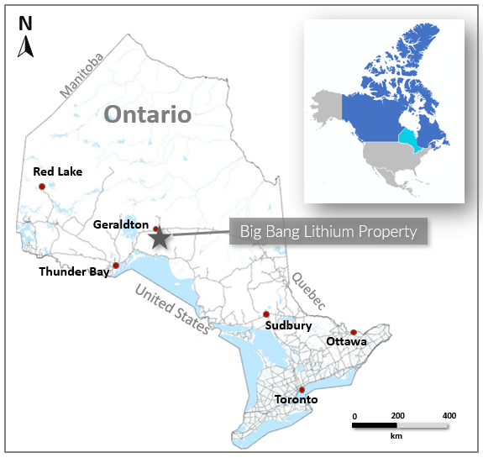
Figure 1: Big Bang Lithium Project location map in NW Ontario, Canada

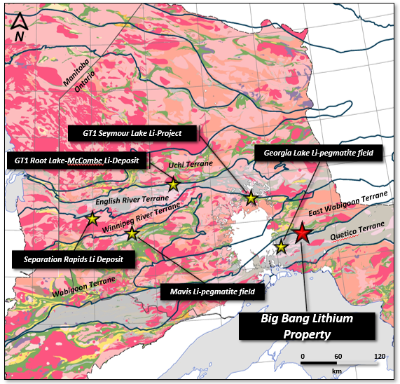
Figure 2: Northwest Ontario Regional Map with select lithium projects and Big Bang Lithium Project
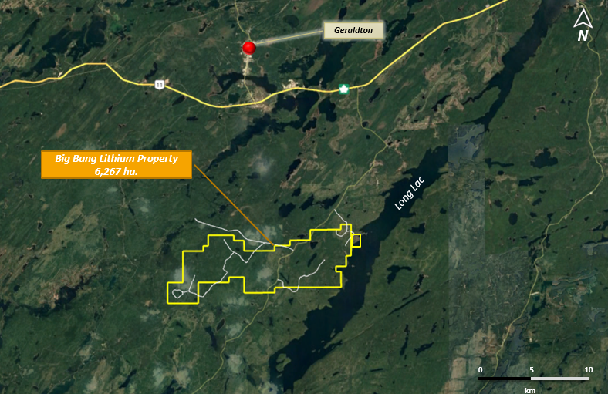
Figure 3: Location and roads to Big Bang Lithium Project

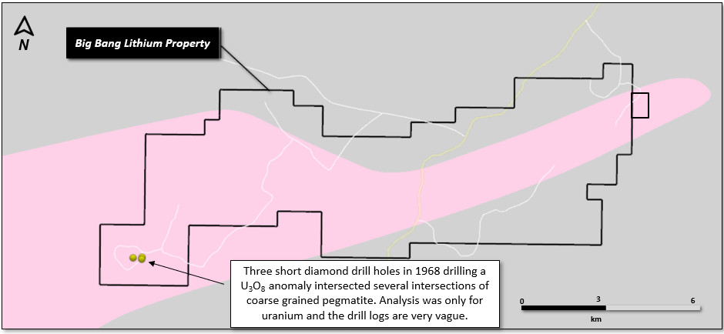
Figure 4: Location of 3 drill holes collared in 1968 testing uranium potential of pegmatites

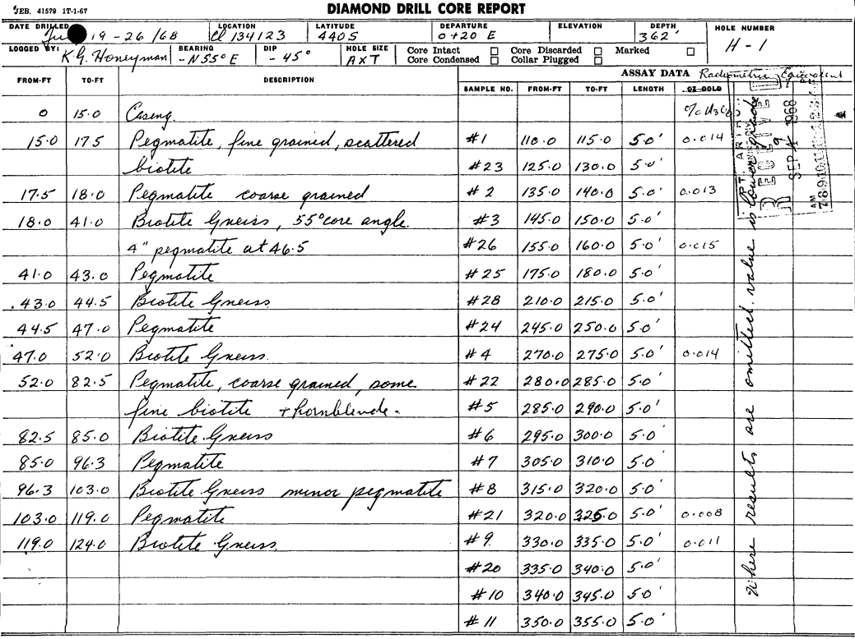
Figure 5 – Chimo Option – July 1968 - Drill Log H1 - uranium exploration (1 of 2)

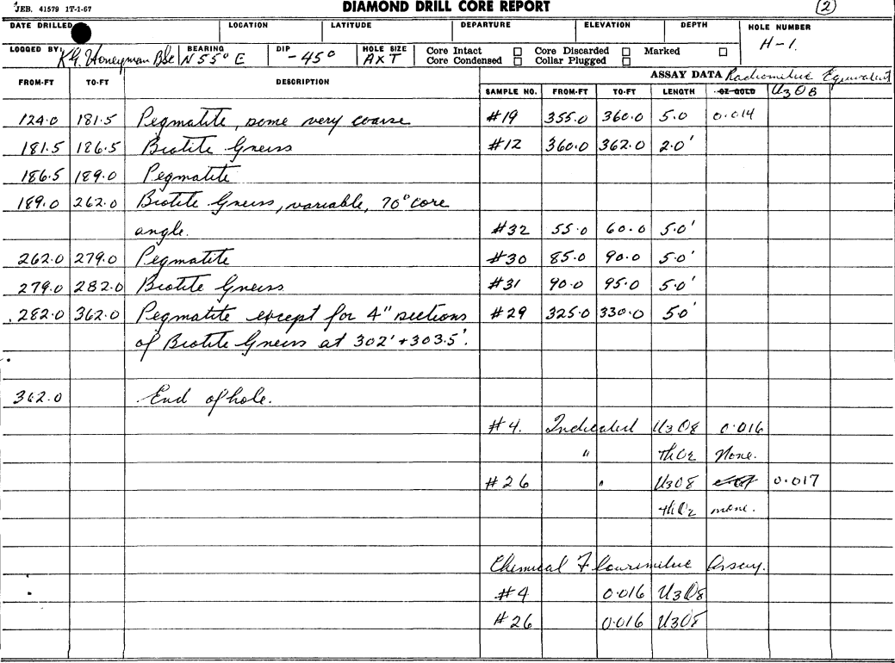
Figure 6 – Chimo Option – July 1968 - Drill Log H1 - uranium exploration (2 of 2)

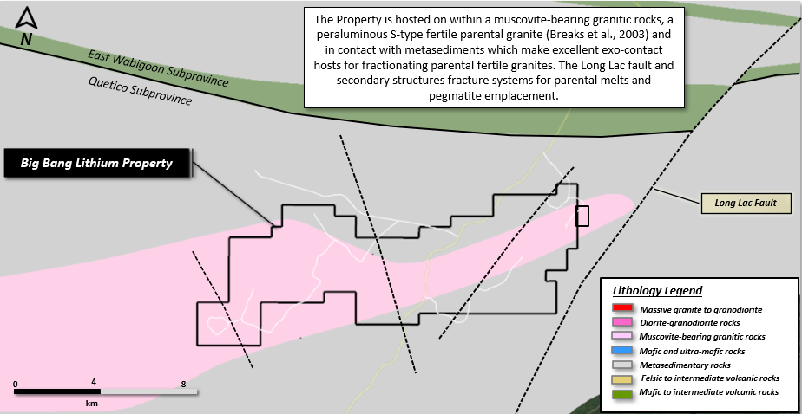
Figure 7 – Geology and structure on the Property
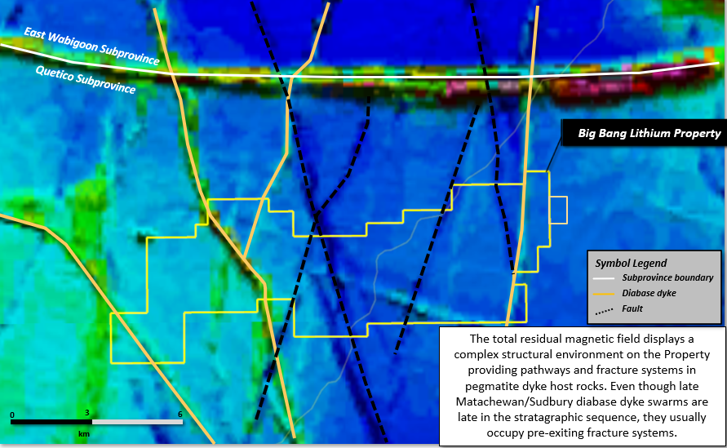
Figure 8 – Total residual magnetic field map showing major structure on the Property

